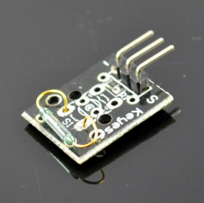
This project will use a Reed switch module to detect magnetic field. When the reed module is closing a magnetic iron, the LED in the circuit will turn off.
Step 1: Connect reed module with Arduino as per following circuit graph:
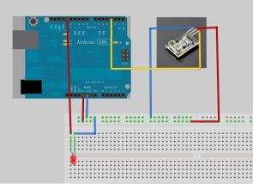
Step 2:Download sample code and load it into Arduino.
Step 3: Run the arduino code and you will see result same as following video:

